Assignment-2
Q. Create a job to deploy index.html to Apache httpd.
Steps:
- Launch EC2 instance with security group allowing SSH and port 8080.
- Connect instance & install java 17
- Download Jenkins repository and then install Jenkins
- Start Jenkins and then setup using public IP
- Now Create a Jenkins Job:
- Click on ‘New Item’
- Enter an item name- Assignment
- Select item type- Freestyle project and click on OK
- And
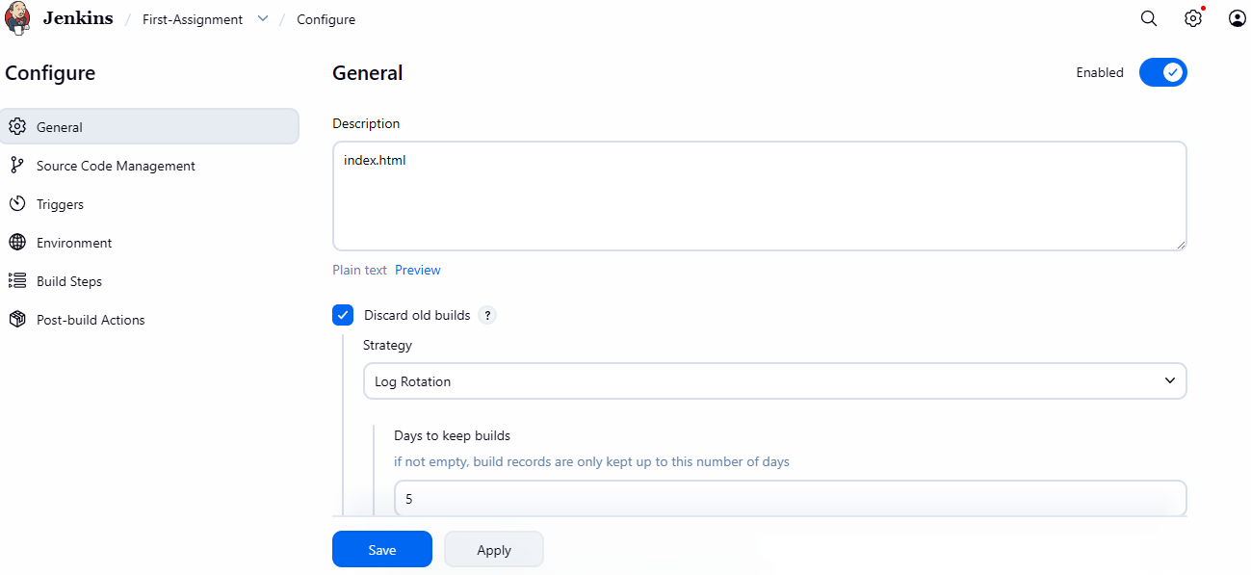

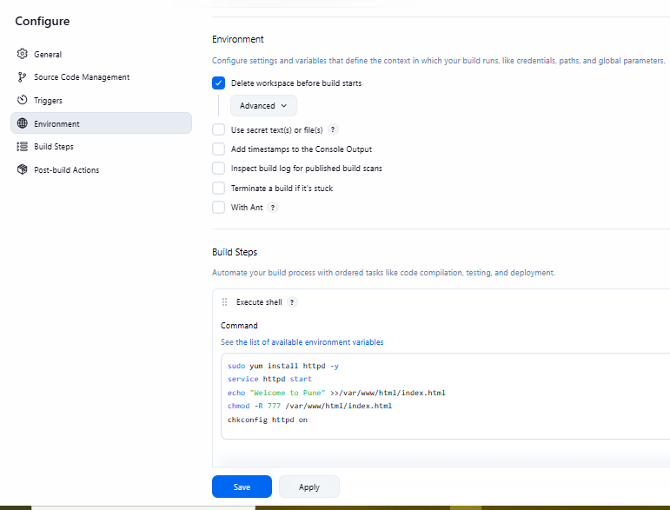

- As sson as you can click on build now, your script will run and httpd will installed & became active
- Now you can use public IP
